# Test Report for Unity-Cinder 01.001.1 Fuel Plugin for MOS 7.x

Revision history 2

Document purpose 3

Test environment 3

Test coverage and metrics 3

Test results summary 3

Type of testing 4

Coverage of features 4

Detailed test run results 4

Known issues 8

# Revision history

|  |  |  |  |
| --- | --- | --- | --- |
| **Version** | **Revision date** | **Editor** | **Comment** |
| 1.0 | 12.16.2016 | Peter Wang(peter.wang13@emc.com) | Add report for Unity Fuel plugin 1.0.0 |
|  |  |  |  |
|  |  |  |  |
|  |  |  |  |

# Document purpose

This document provides test run results for *Unity Fuel plugin 1.0.0 on Mirantis OpenStack 7.x*

# Test environment

*The test environment shall include 6 VMs within a KVM or Virtualbox based environment. Following is an example of designations for the VMs:*

1. Fuel master node (w/ 50GB Disk, 2 Network interfaces [Mgmt, PXE] )
2. OpenStack Controller #1 node
3. OpenStack Controller #2 node
4. OpenStack Compute node (60GB disk)
5. OpenStack Cinder(CEPH-OSD) node1 (100GB disk)
6. OpenStack Cinder(CEPH-OSD) node2 (100GB disk)

Each VM shall have 2CPUs, 4GB RAM, 70GB disk (except where noted), 3 Network interfaces (except where noted). There are 5 different networks type setup on these interfaces:

1. PXE Network
2. Public Network
3. Private Network
4. Management Network
5. Storage Network

The Storage network shall be connected to the Unity iSCSI ports to provide Unity data path for Compute nodes and Controller nodes.

# Test coverage and metrics

*There are a lines inserted into the cinder.conf and the cinder-volume service requires a restart. Verify that all lines are inserted and that the cinder-volume service has restarted with Unity configured for 100% coverage.*

# Test results summary

All tests passed. All lines were properly inserted into the cinder.conf file on all controller nodes and all cinder-volume services were restarted on all nodes.

|  |  |
| --- | --- |
| **Parameter** | **Value** |
| Total quantity of executed test cases | 6 |
| Total quantity of not executed test cases | 0 |
| Quantity of automated test cases | 0 |
| Quantity of not automated test cases | 6 |

# Detailed test run results

|  |  |  |  |  |  |
| --- | --- | --- | --- | --- | --- |
| **#** | **Test case ID** | **Passed** | **Failed** | **Skipped** | **Comment** |
| 1 | install_plugin_deploy_env | ✓ |  |  |  |
| 2 | modify_env_with_plugin_remove_add_controller | ✓ |  |  |  |
| 3 | modify_env_with_plugin_remove_add_compute | ✓ |  |  |  |
| 4 | upgrade_mos_with_enabled_plugin | ✓ |  |  |  |
| 5 | uninstall_plugin_with_deployed_env | ✓ |  |  |  |
| 6 | uninstall_plugin | ✓ |  |  |  |
| Total |  | 6 |  |  |  |
| Total, % |  | 100 |  |  |  |

# Test Logs

## Resinstall_plugin_deploy_env

|  |
| --- |
| [root@fuel ~]# fuel plugins --install /tmp/cinder-unity-1.0-1.0.0-1.noarch.rpm  Loaded plugins: fastestmirror, priorities  Examining /tmp/cinder-unity-1.0-1.0.0-1.noarch.rpm: cinder-unity-1.0-1.0.0-1.noarch  Marking /tmp/cinder-unity-1.0-1.0.0-1.noarch.rpm to be installed  Resolving Dependencies  --> Running transaction check  ---> Package cinder-unity-1.0.noarch 0:1.0.0-1 will be installed  --> Finished Dependency Resolution  Dependencies Resolved  ==================================================================================================================================================================================  Package Arch Version Repository Size  ==================================================================================================================================================================================  Installing:  cinder-unity-1.0 noarch 1.0.0-1 /cinder-unity-1.0-1.0.0-1.noarch 1.8 M  Transaction Summary  ==================================================================================================================================================================================  Install 1 Package  Total size: 1.8 M  Installed size: 1.8 M  Downloading packages:  Running transaction check  Running transaction test  Transaction test succeeded  Running transaction  Installing : cinder-unity-1.0-1.0.0-1.noarch 1/1  Verifying : cinder-unity-1.0-1.0.0-1.noarch 1/1  Installed:  cinder-unity-1.0.noarch 0:1.0.0-1  Complete!  Plugin /tmp/cinder-unity-1.0-1.0.0-1.noarch.rpm was successfully installed.  # fuel plugins  id | name | version | package_version | releases  ---+--------------+---------+-----------------+-----------------------------------------------  1 | cinder-unity | 1.0.0 | 3.0.0 | ubuntu (2015.1.0-7.0, liberty-8.0, mitaka-9.0) |

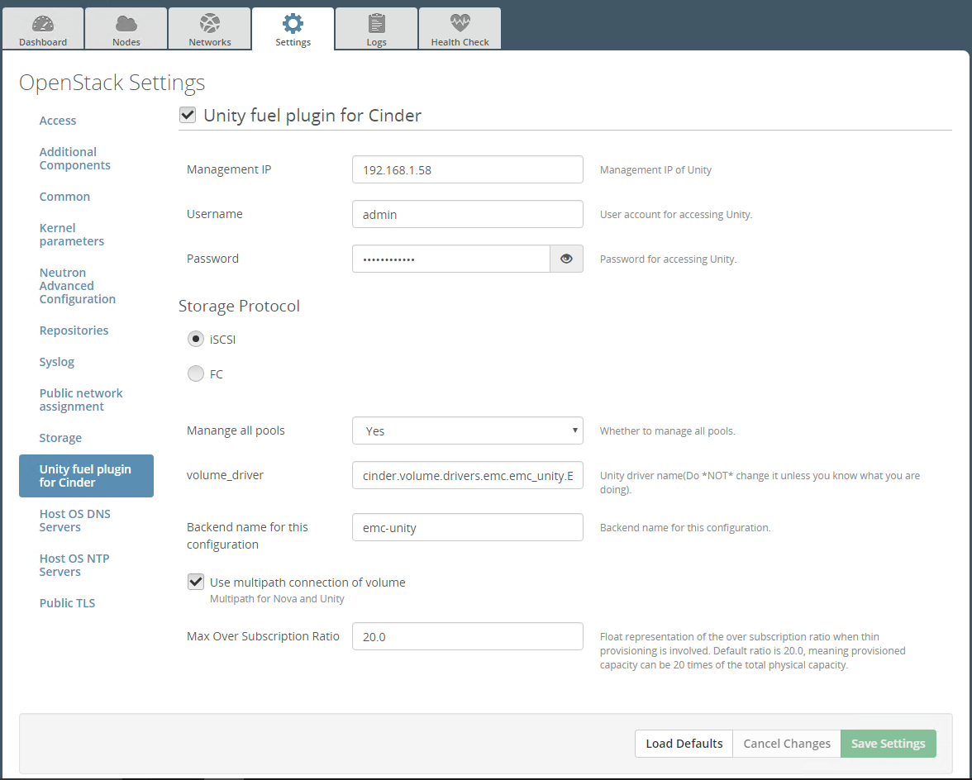

Figure 1: configure the unity fuel plugin via GUI

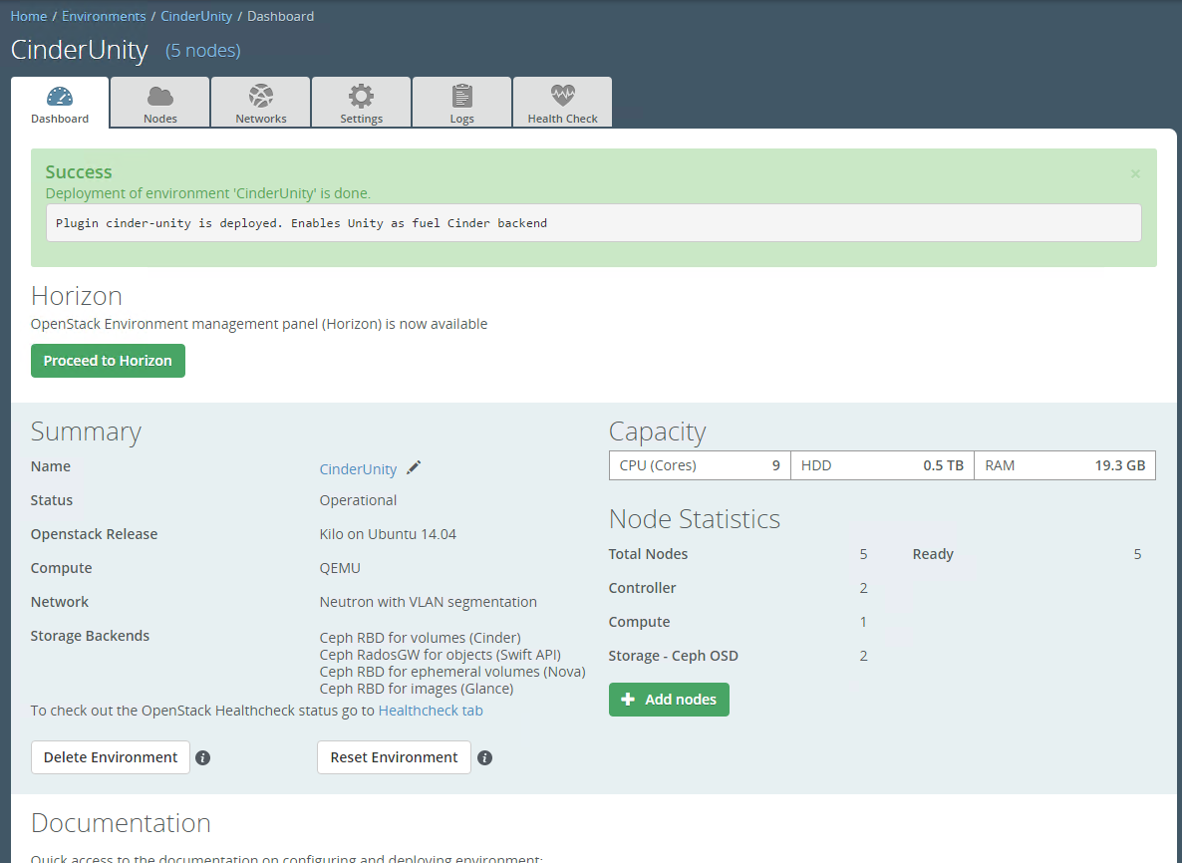

Figure 2: Plugin is installed successfully.

## modify_env_with_plugin_remove_add_controller

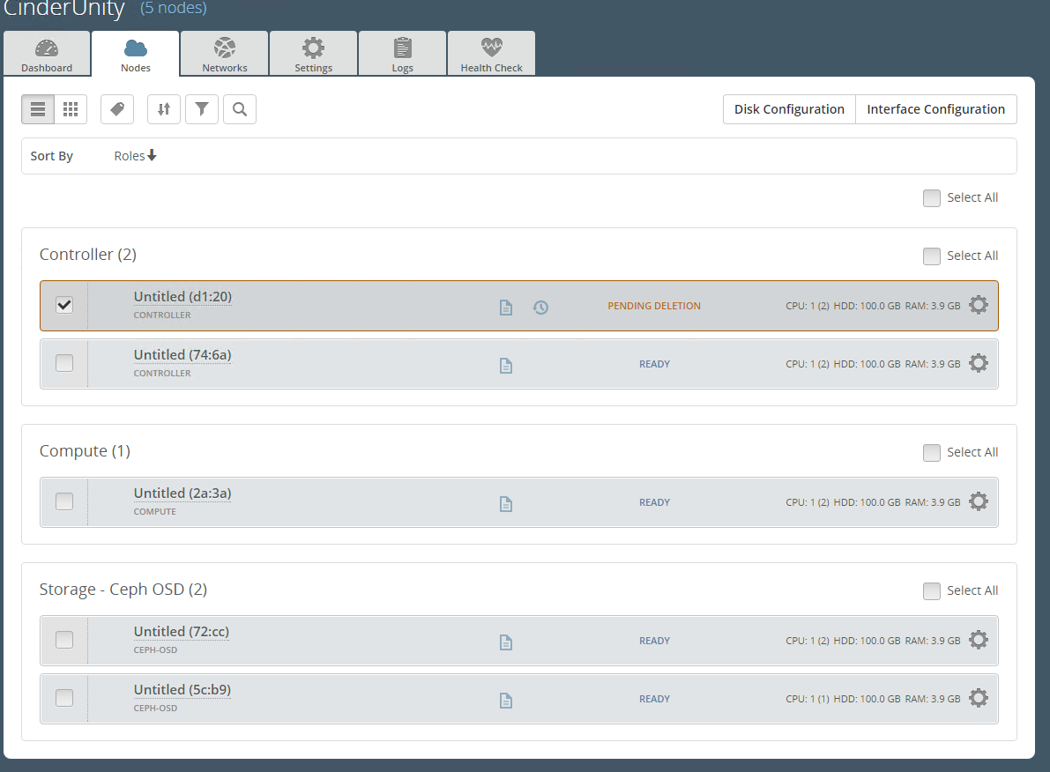

Figure 3: remove 1 controller

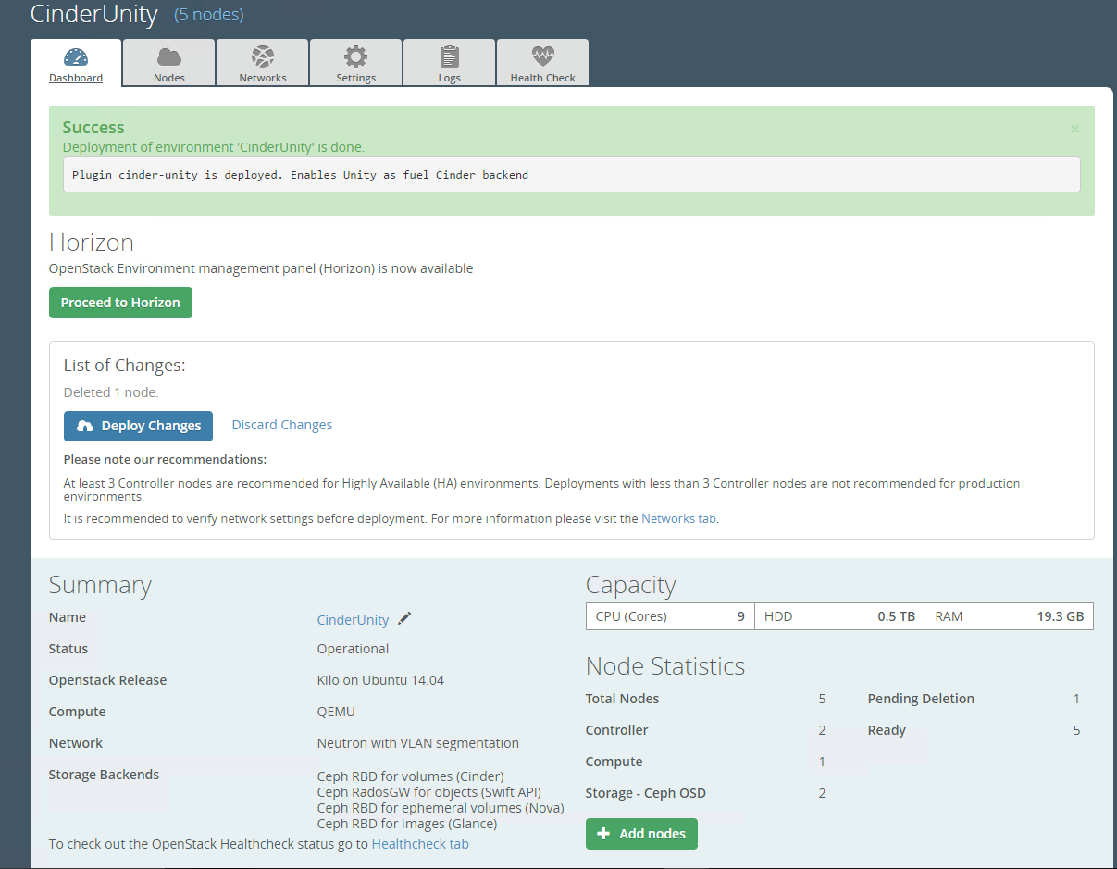

Figure 4: Remove 1 controller and deploy

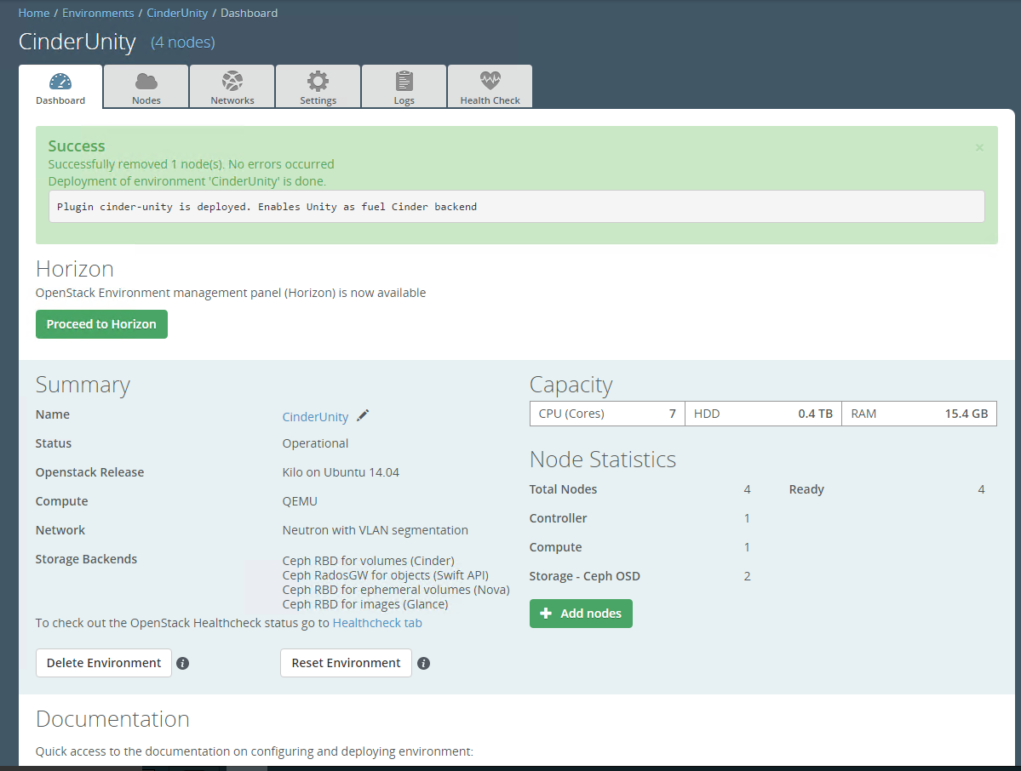

Figure 5: remove successfully

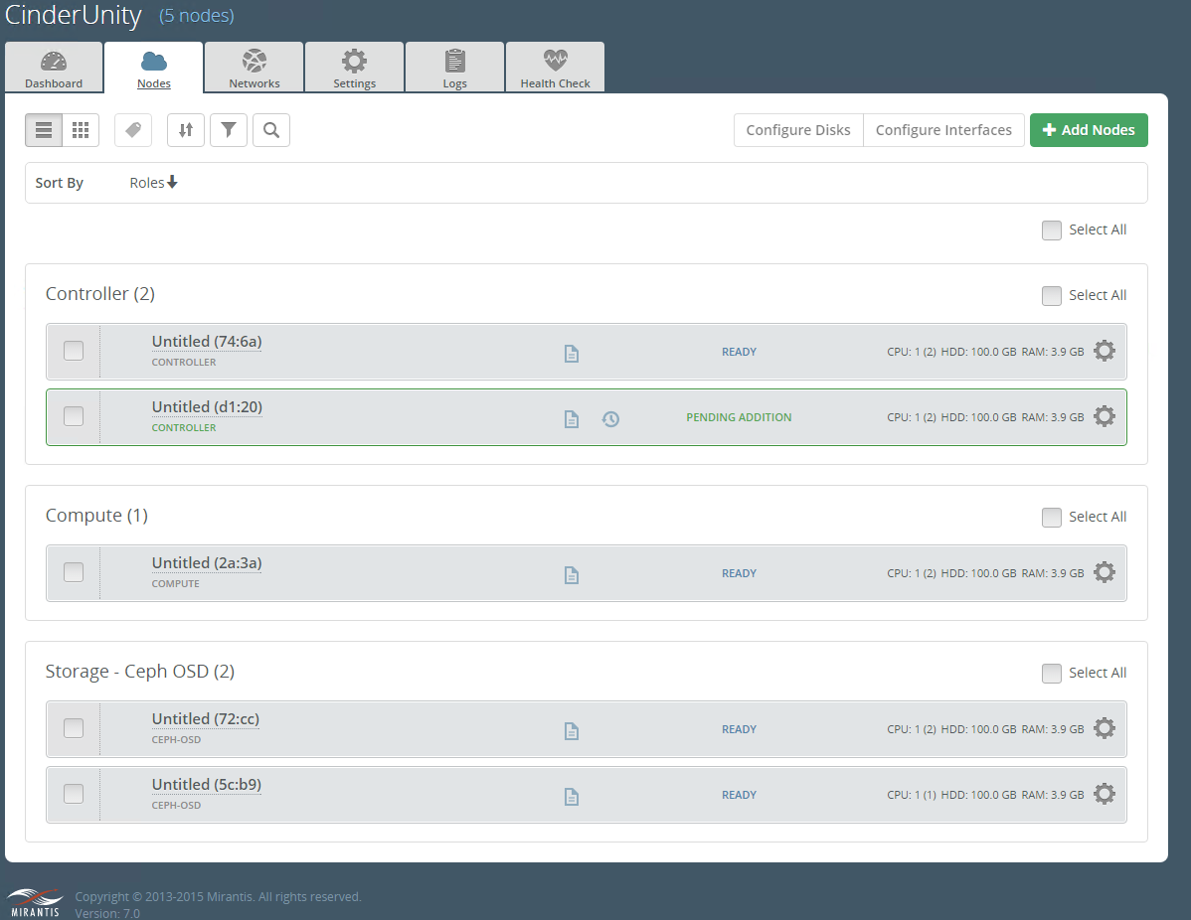

Figure 6: Add 1 controller

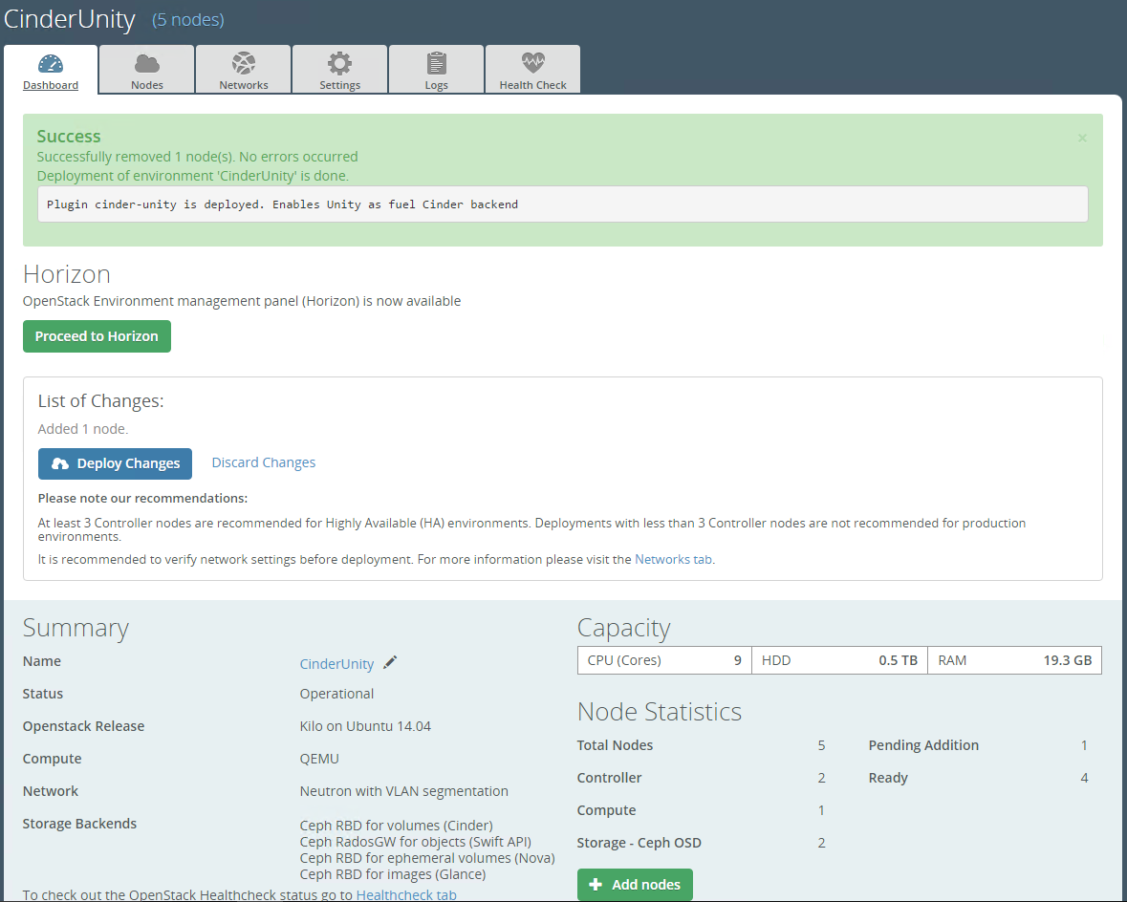

Figure 7: Add 1 controller and deploy

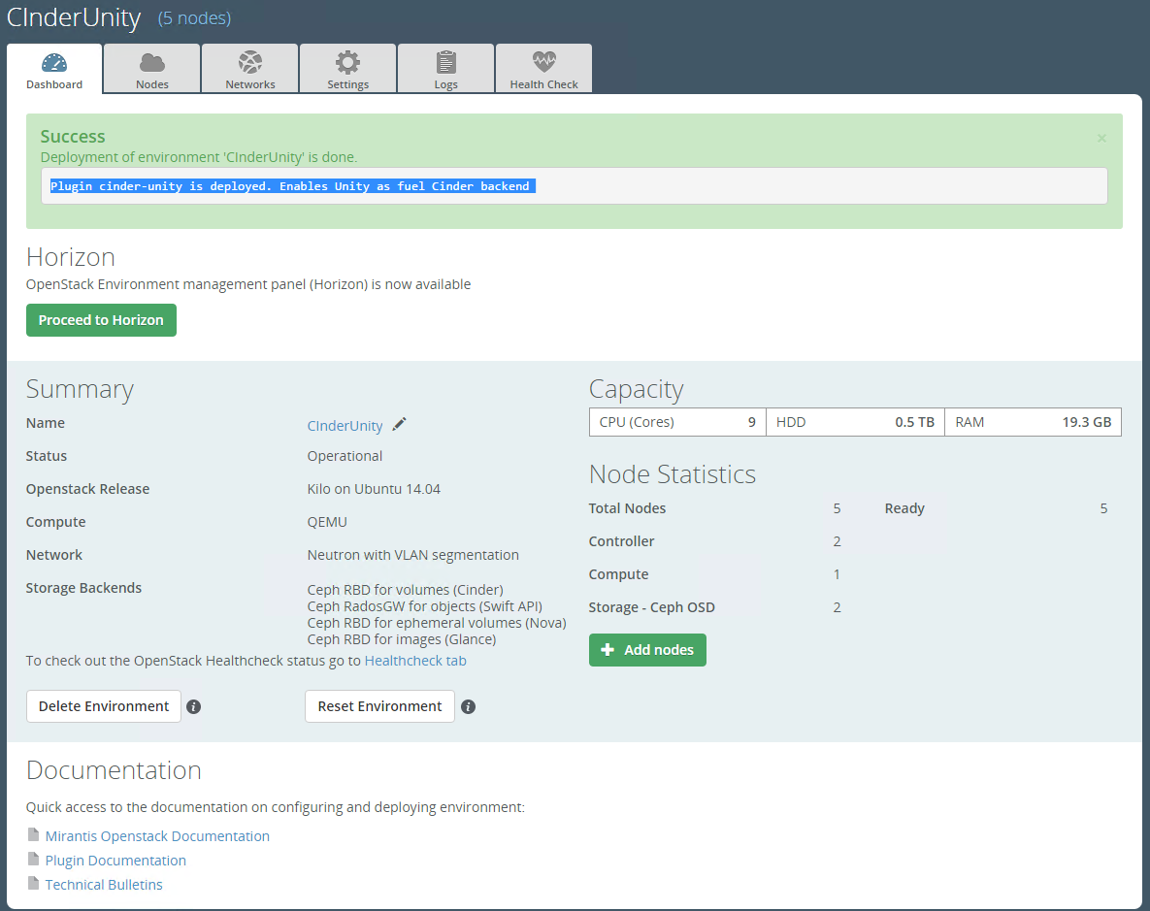

## modify_env_with_plugin_remove_add_compute

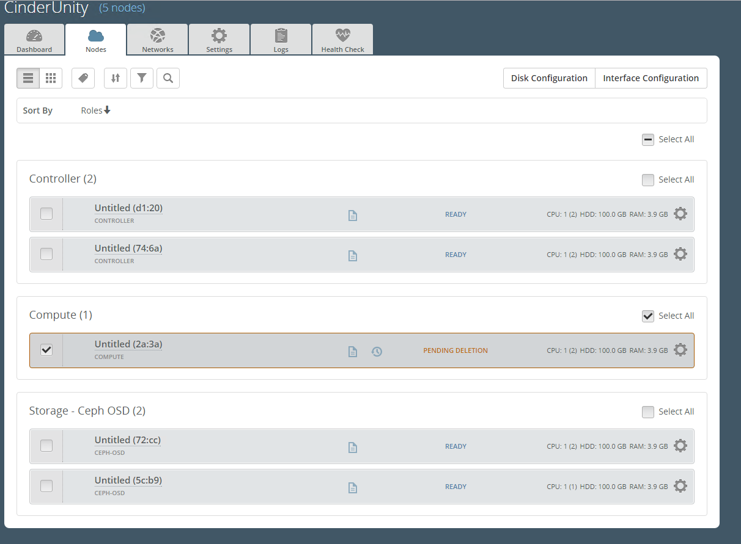

Figure 8: Remove 1 compute node

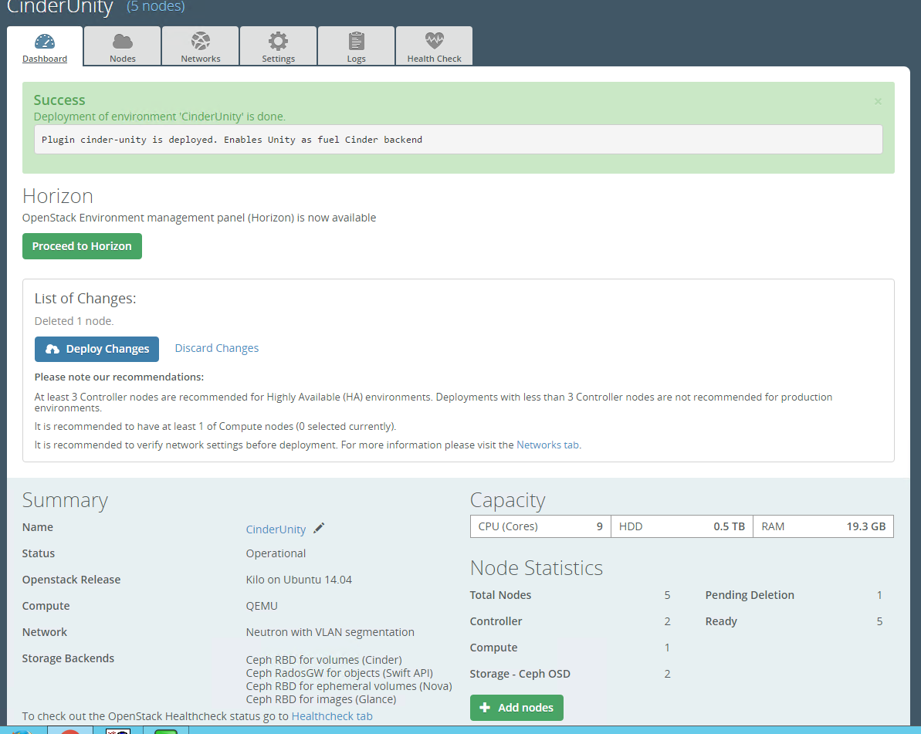

Figure 9. Remove 1 compute node and deploy

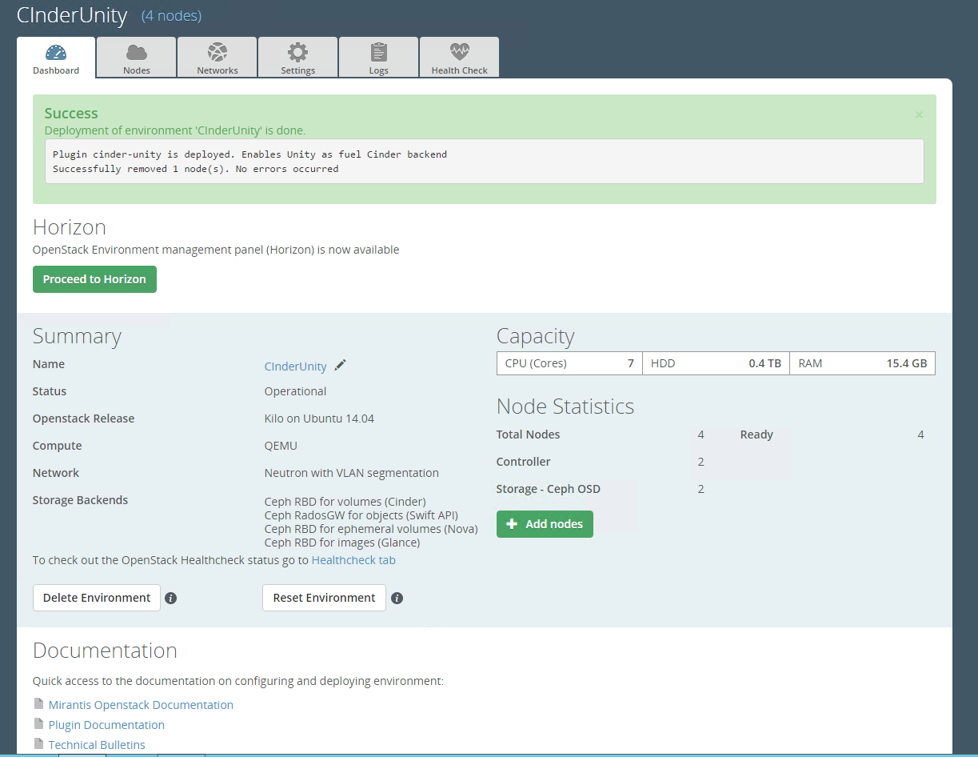

Figure 10. Remove 1 compute node successfully.

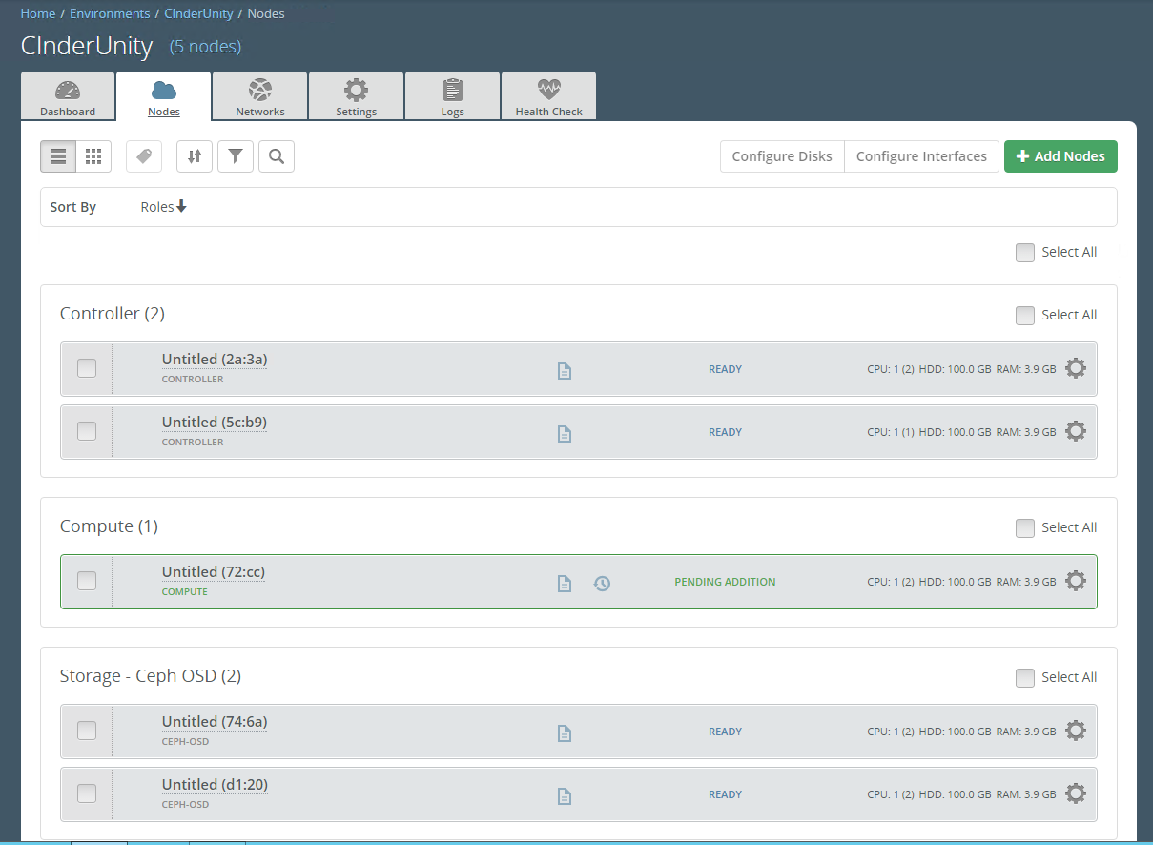

Figure 11: add 1 compute

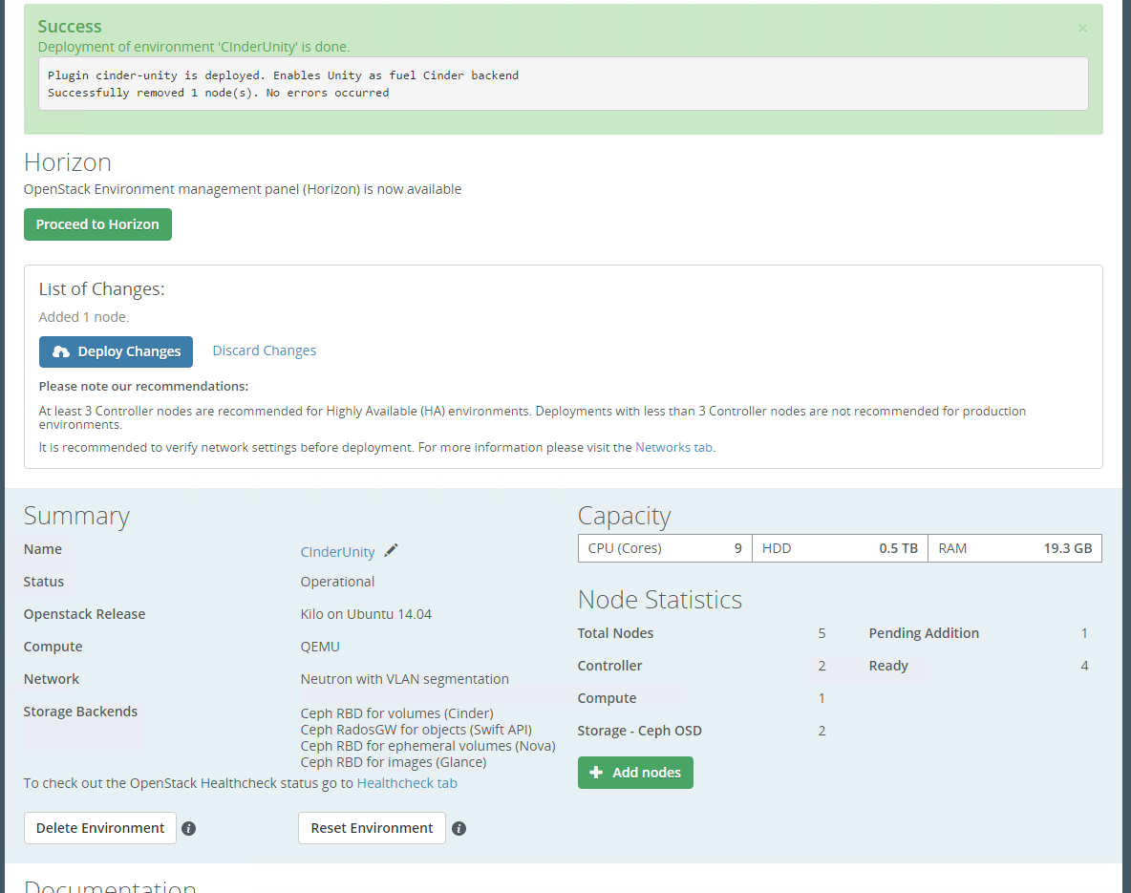

Figure 12: add 1 compute and deploy



Figure 13: add 1 compute successfully

## upgrade_mos_with_enabled_plugin

|  |
| --- |
| # make sure openstack components were upgraded  root@node-22:~# cinder-manage --version  2015.1.1  root@node-25:~# nova-manage --version  2015.1.1  # performance cinder command, to make sure Unity plugin still works for new environment  root@node-22:~# cinder create --display-name volume-after-upgrade 10  +---------------------+--------------------------------------+  | Property | Value |  +---------------------+--------------------------------------+  | attachments | [] |  | availability_zone | nova |  | bootable | false |  | created_at | 2017-01-15T00:34:51.041905 |  | display_description | None |  | display_name | volume-after-upgrade |  | encrypted | False |  | id | d8e82632-f518-4b16-8c35-4a03170c82e4 |  | metadata | {} |  | multiattach | false |  | size | 10 |  | snapshot_id | None |  | source_volid | None |  | status | creating |  | volume_type | None |  +---------------------+--------------------------------------+  root@node-22:~# cinder list  +--------------------------------------+-----------+----------------------+------+-------------+----------+-------------+  | ID | Status | Display Name | Size | Volume Type | Bootable | Attached to |  +--------------------------------------+-----------+----------------------+------+-------------+----------+-------------+  | 71a36c99-1d84-4f01-aaf1-927ae1914f37 | available | unity-volume1 | 1 | unity | false | |  | d8e82632-f518-4b16-8c35-4a03170c82e4 | creating | volume-after-upgrade | 10 | None | false | |  +--------------------------------------+-----------+----------------------+------+-------------+----------+-------------+  root@node-22:~# cinder list  +--------------------------------------+-----------+----------------------+------+-------------+----------+-------------+  | ID | Status | Display Name | Size | Volume Type | Bootable | Attached to |  +--------------------------------------+-----------+----------------------+------+-------------+----------+-------------+  | 71a36c99-1d84-4f01-aaf1-927ae1914f37 | available | unity-volume1 | 1 | unity | false | |  | d8e82632-f518-4b16-8c35-4a03170c82e4 | available | volume-after-upgrade | 10 | None | false | |  +--------------------------------------+-----------+----------------------+------+-------------+----------+-------------+ |

## uninstall_plugin_with_deployed_env

|  |
| --- |
| [root@fuel ~]# fuel plugins --remove cinder-unity==1.0.0  400 Client Error: Bad Request for url: http://30.0.0.2:8000/api/v1/plugins/1 (Can't delete plugin which is enabled for some environment.) |

## uninstall_plugin

|  |
| --- |
| [root@fuel ~]# fuel plugins --remove cinder-unity==1.0.0  Loaded plugins: fastestmirror, priorities  Repodata is over 2 weeks old. Install yum-cron? Or run: yum makecache fast  Resolving Dependencies  --> Running transaction check  ---> Package cinder-unity-1.0.noarch 0:1.0.0-1 will be erased  --> Finished Dependency Resolution  Dependencies Resolved  ==================================================================================================================================================================================  Package Arch Version Repository Size  ==================================================================================================================================================================================  Removing:  cinder-unity-1.0 noarch 1.0.0-1 @/cinder-unity-1.0-1.0.0-1.noarch 1.8 M  Transaction Summary  ==================================================================================================================================================================================  Remove 1 Package  Installed size: 1.8 M  Downloading packages:  Running transaction check  Running transaction test  Transaction test succeeded  Running transaction  Erasing : cinder-unity-1.0-1.0.0-1.noarch 1/1  Verifying : cinder-unity-1.0-1.0.0-1.noarch 1/1  Removed:  cinder-unity-1.0.noarch 0:1.0.0-1  Complete!  Plugin cinder-unity==1.0.0 was successfully removed. |

## Known issues

* *None*